How to Set Up CloudWatch Alerts to Email

CloudWatch itself does not directly send emails — it sends alerts using SNS (Simple Notification Service).

So, the process is:
➡️ CloudWatch Alarm → SNS Topic → Email Notification

STEP 1: Create an SNS Topic for Email Alerts
- Go to AWS Console → SNS
- From left menu → Click Topics
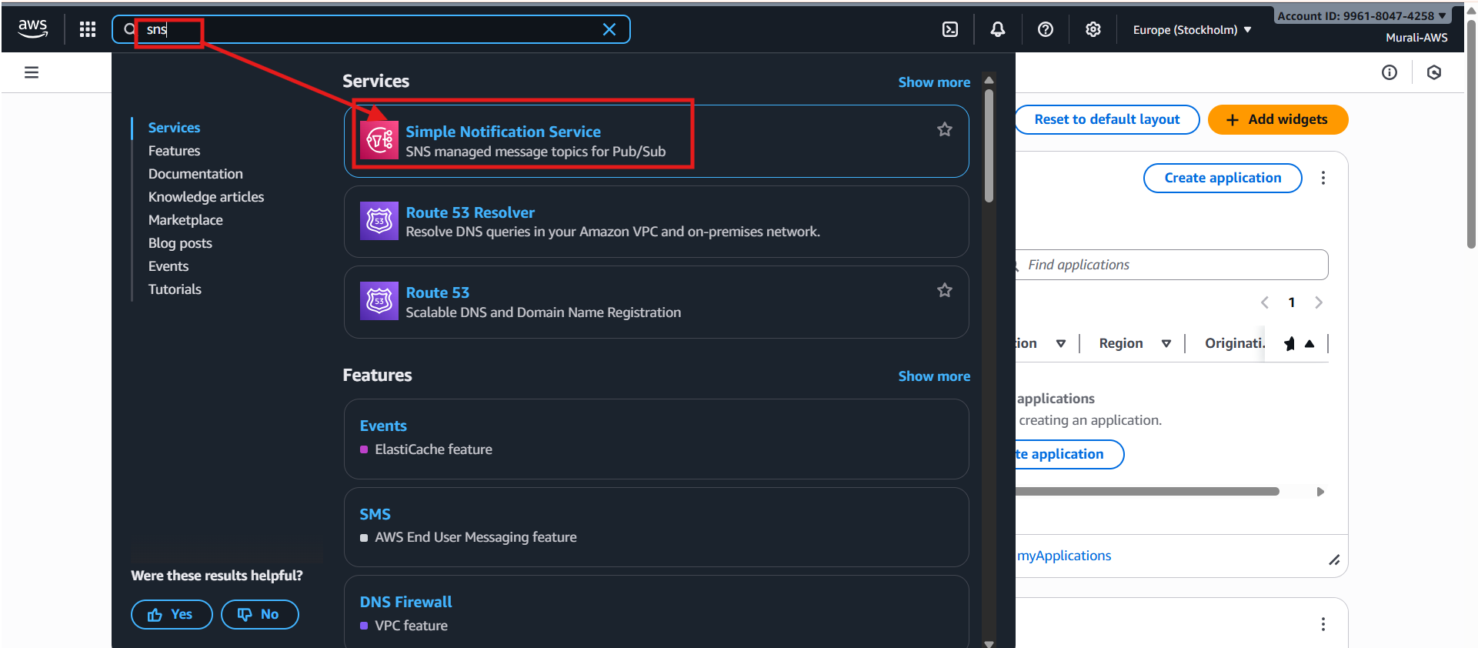

- Click Create topic
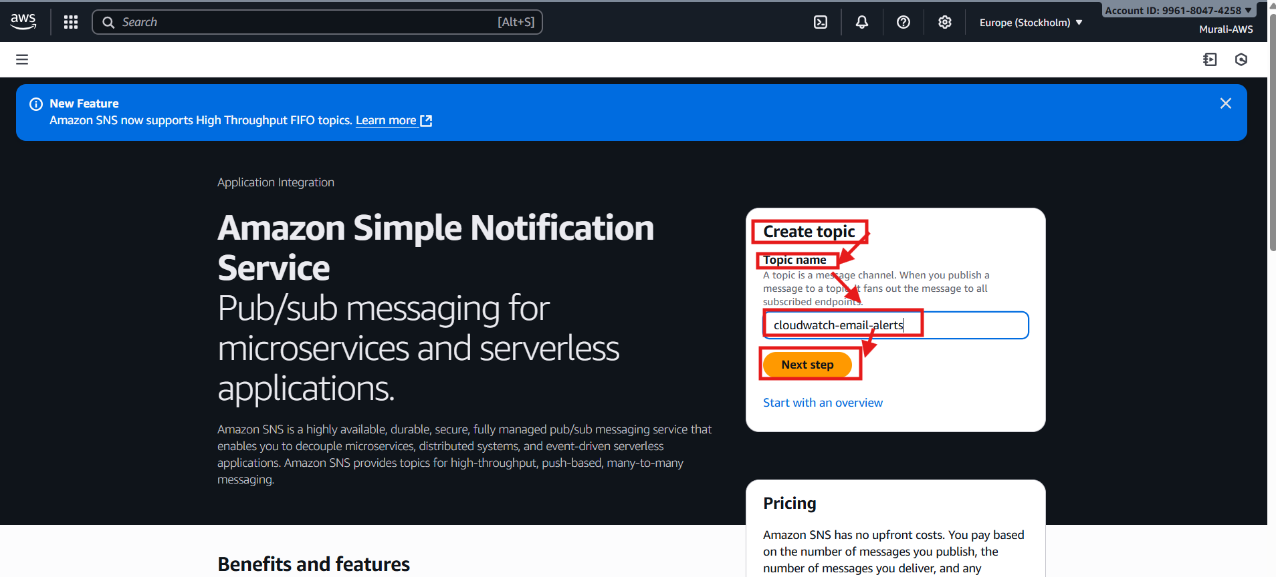
- Choose: Standard
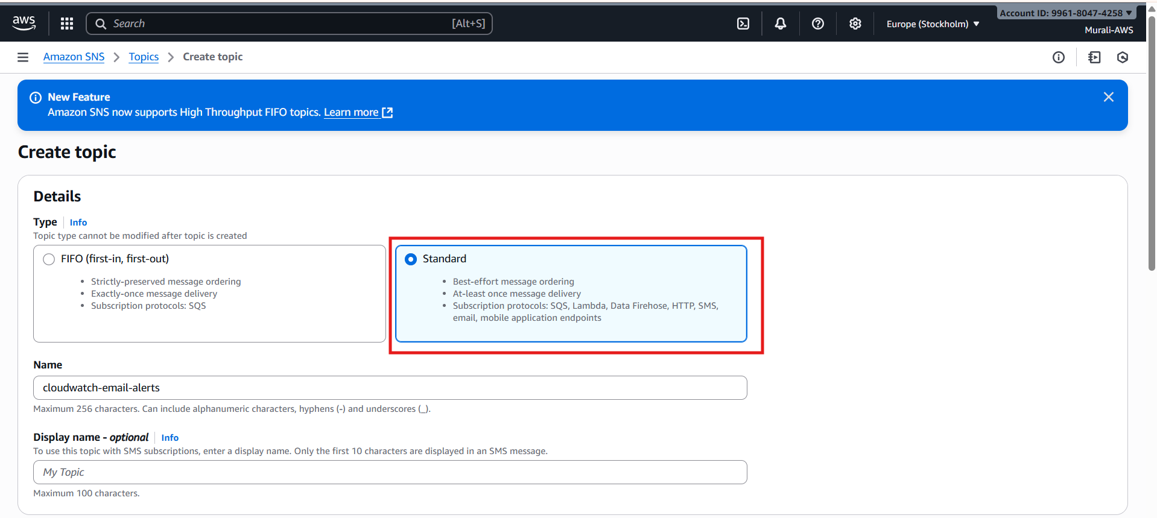
- Enter a name (example: cloudwatch-email-alerts)
- Click Create topic
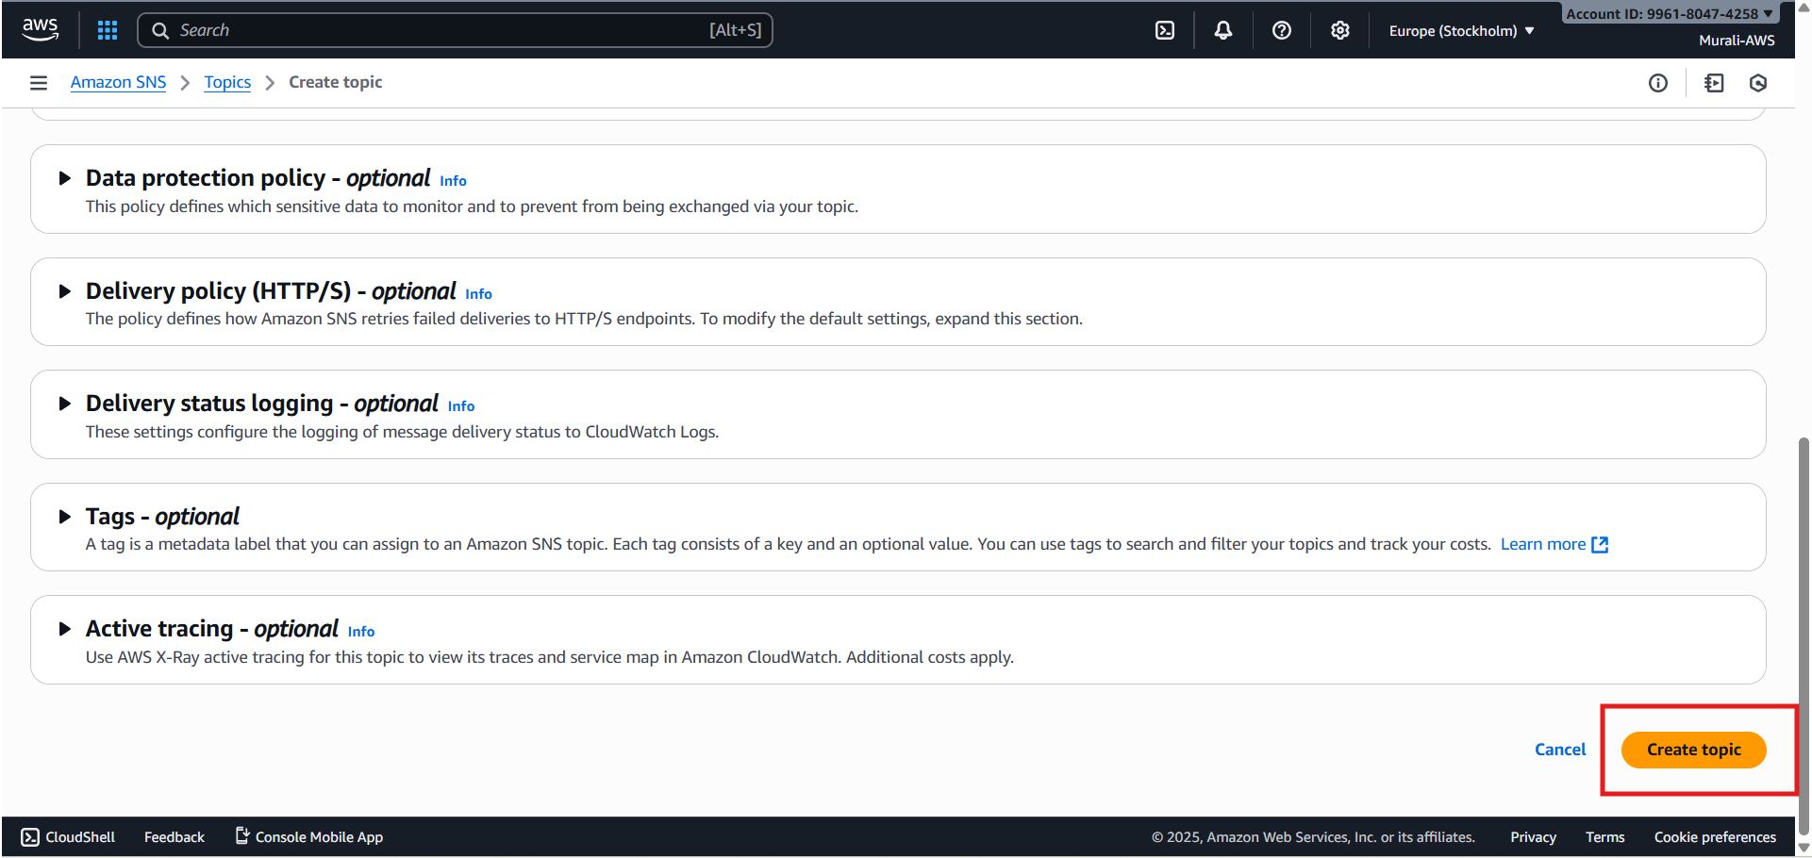
- Topic created
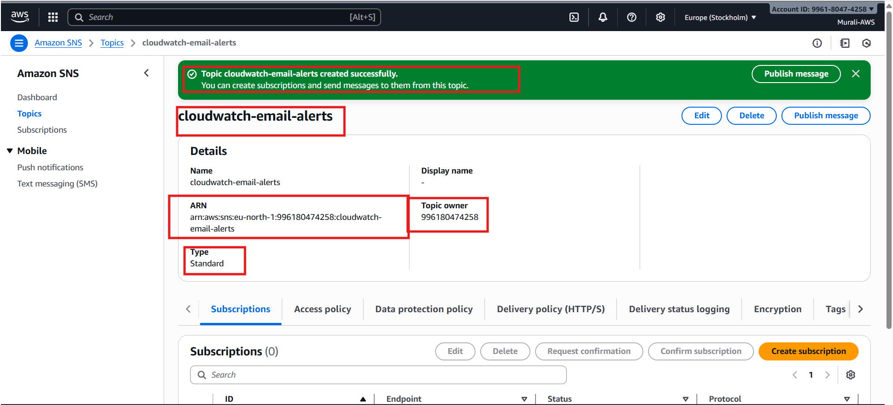

STEP 2: Add Email Subscription to SNS Topic
- After the topic is created → Open it
- Click Create subscription
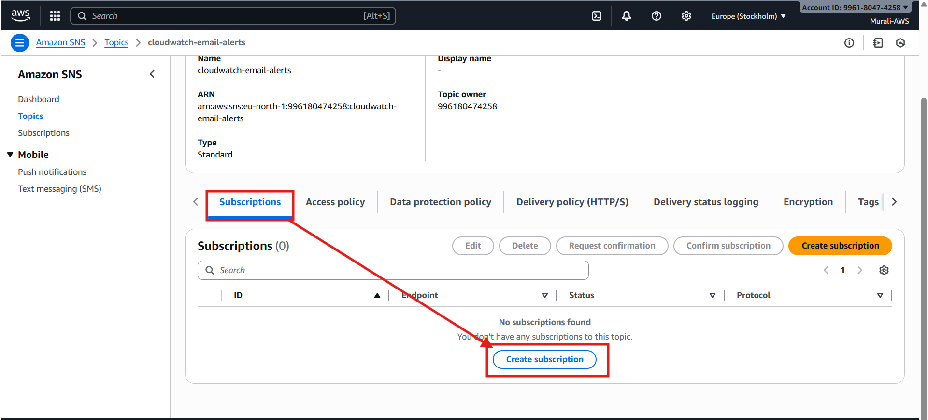
- Set:
  - Protocol → Email
  - Endpoint → enter your email address
- Click Create subscription

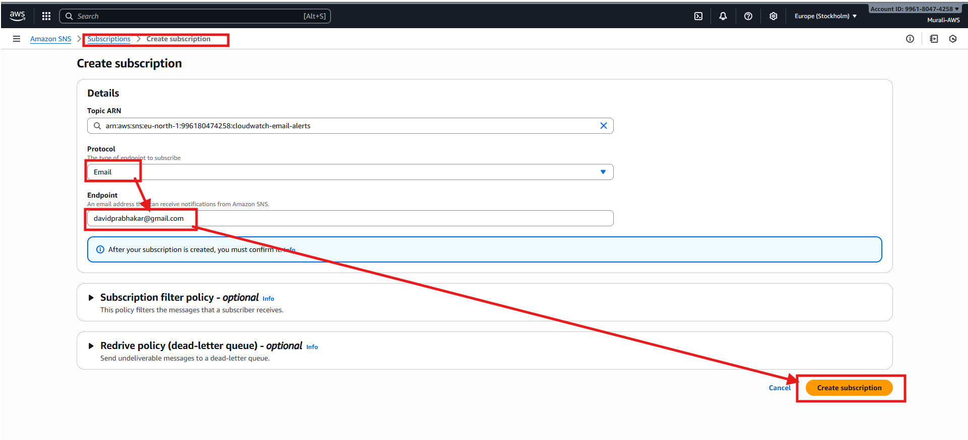

- Email subscription created
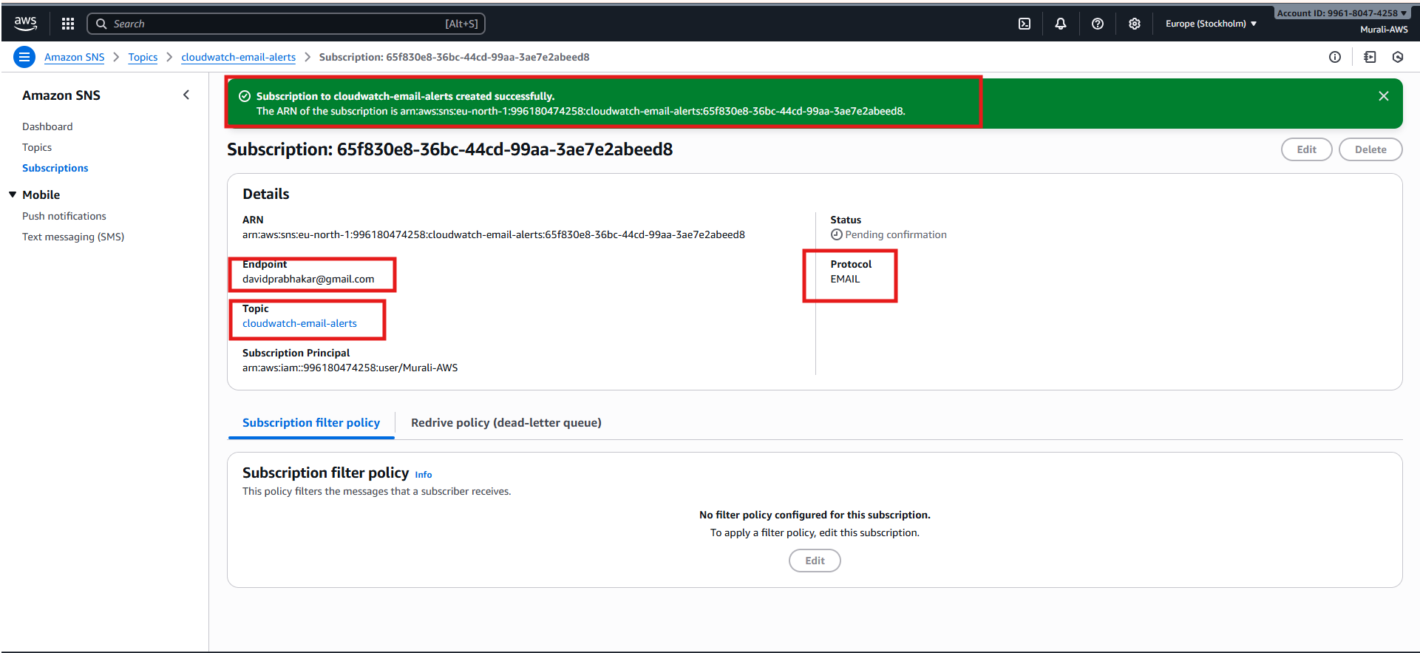

👉 IMPORTANT:
You will receive an email with subject “AWS Notification – Subscription Confirmation”
- Open the email → click Confirm subscription
Your SNS topic is now ready to receive CloudWatch alerts.

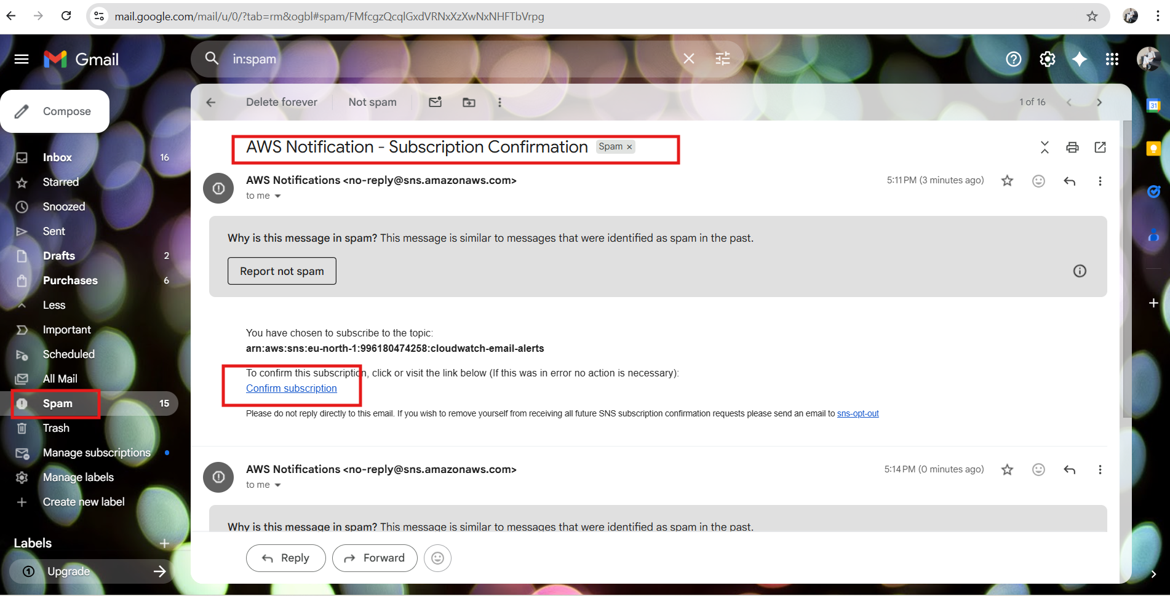

- Subscription confirmed
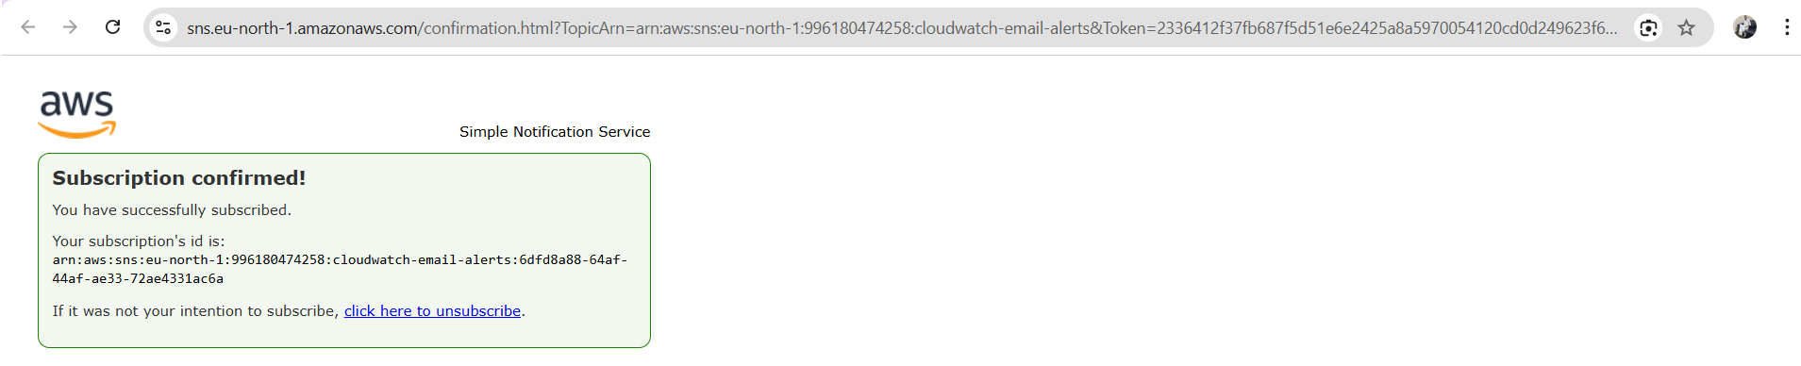

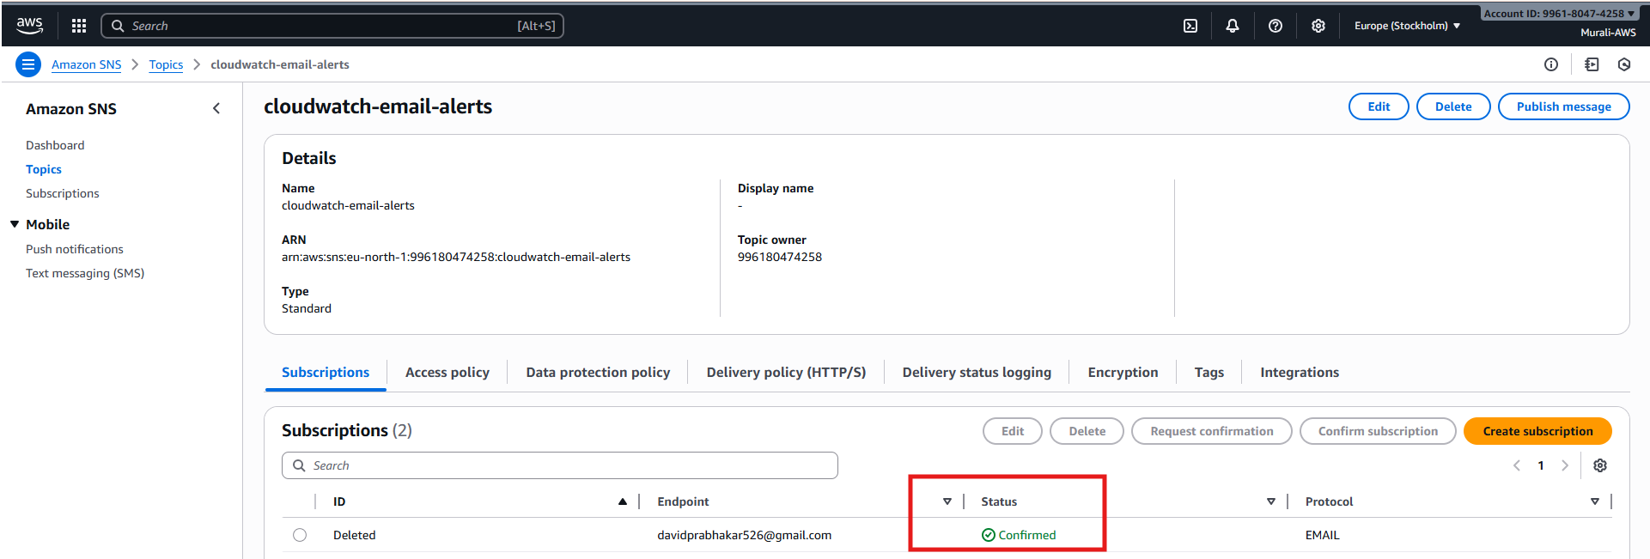
How to Create Dashboard in Cloud Watch
- Go to cloud watch svc dashboard
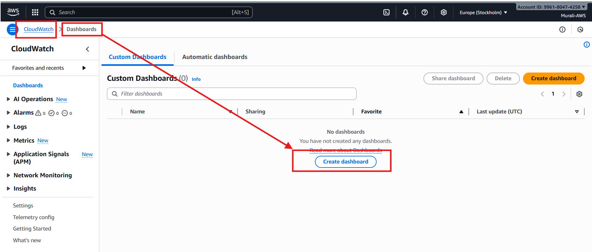

- Click on create dashboard
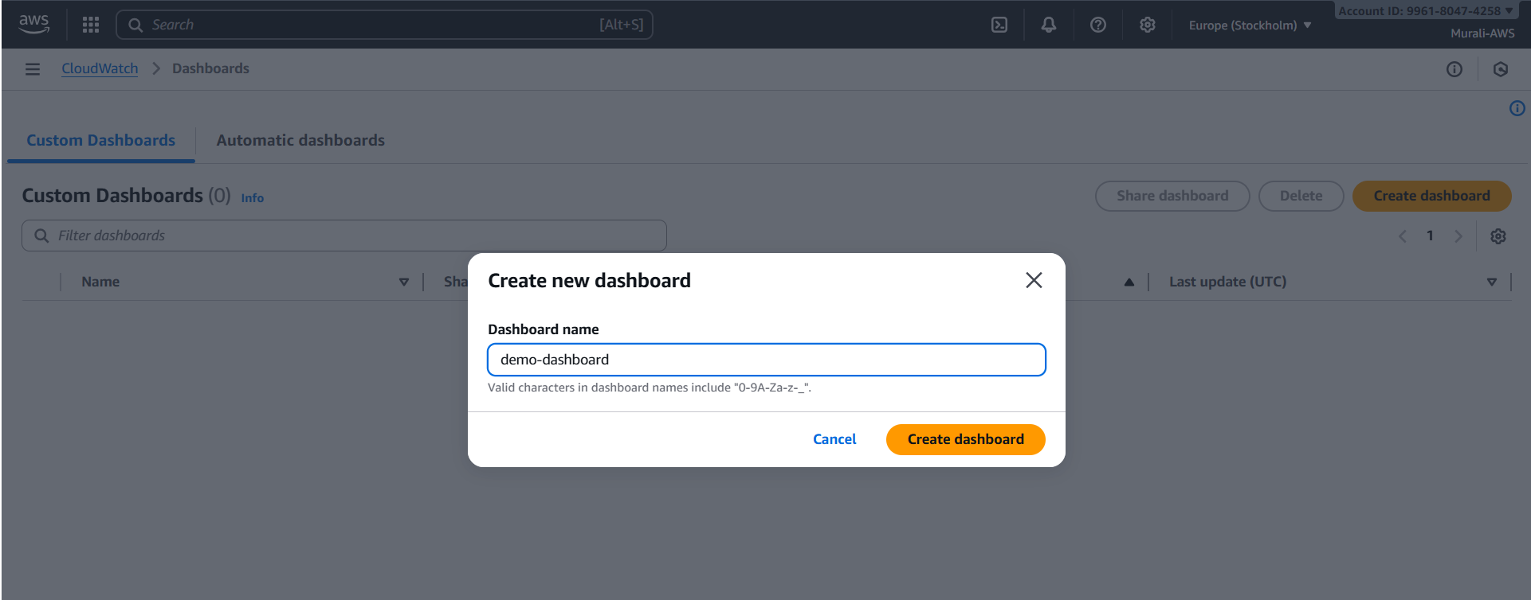
- Choose following configurations
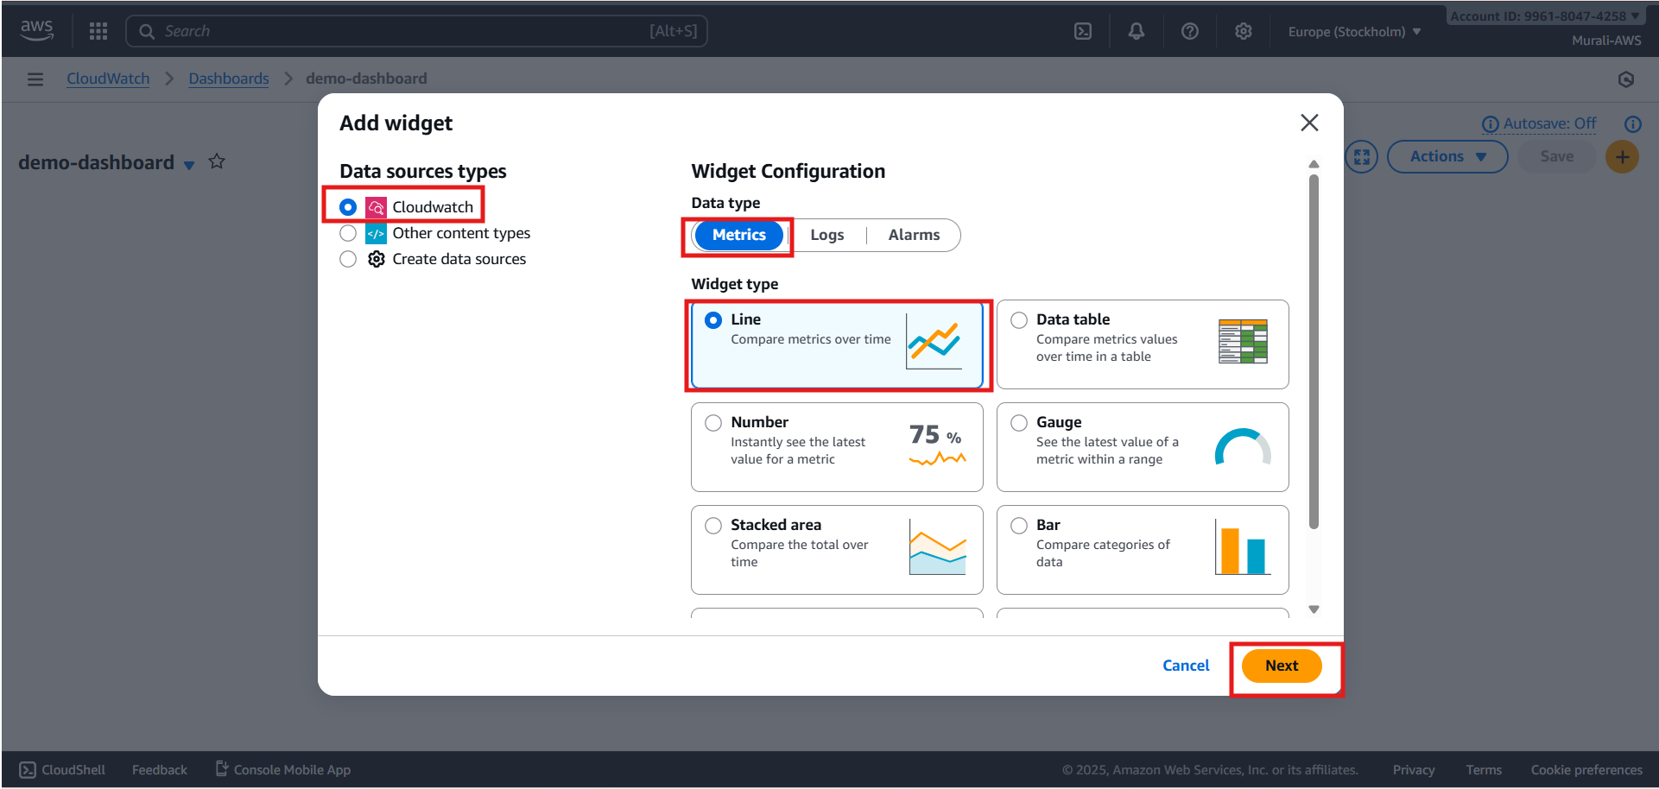
- Add metrics as many as you want
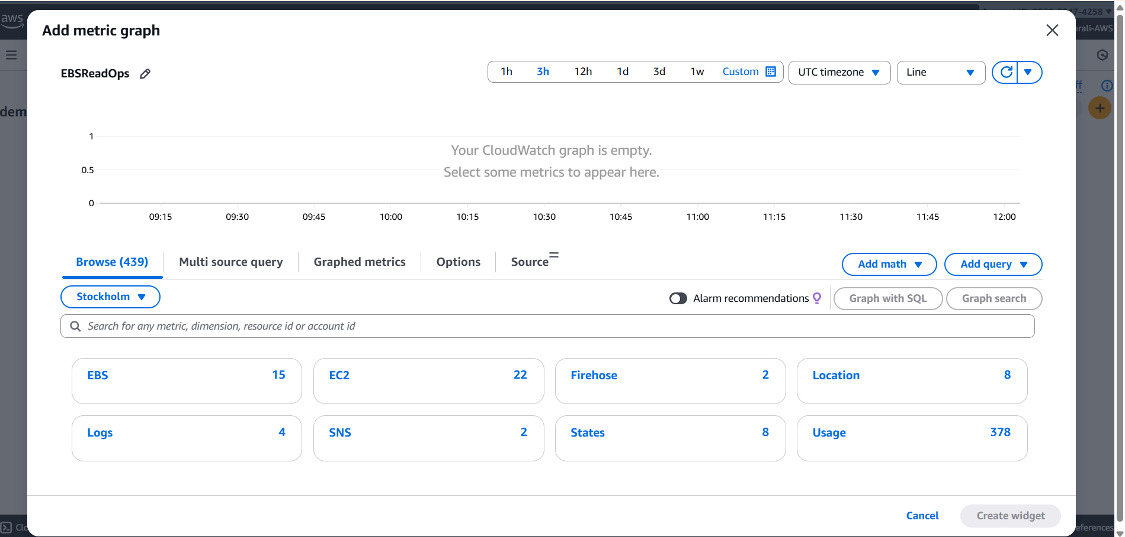

- Choose following configurations and click on create widget
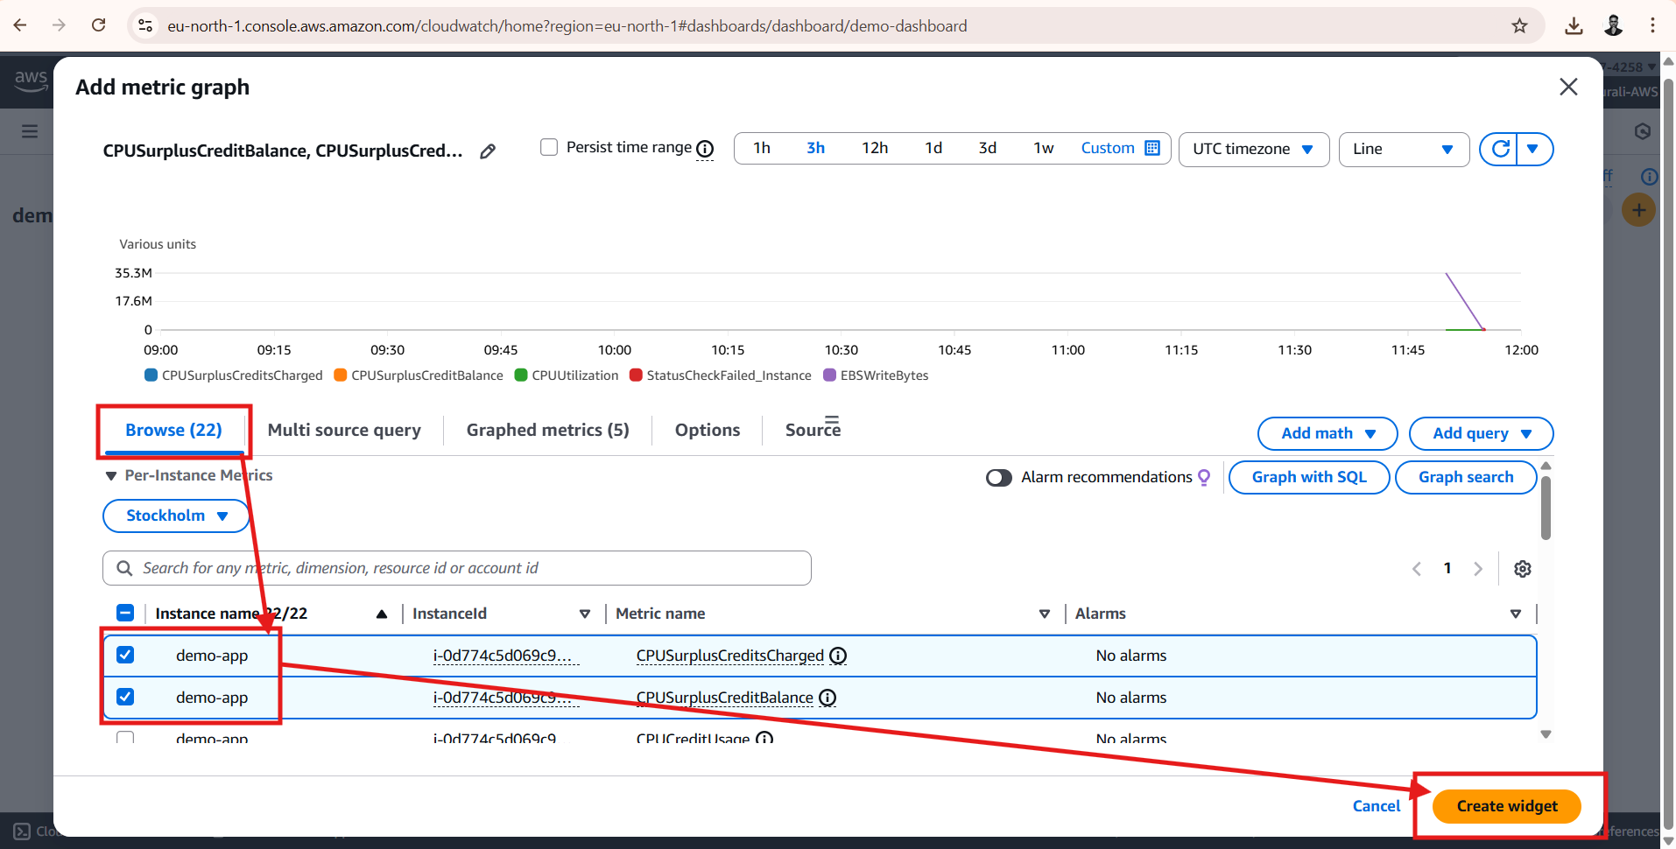

- Dashboard created
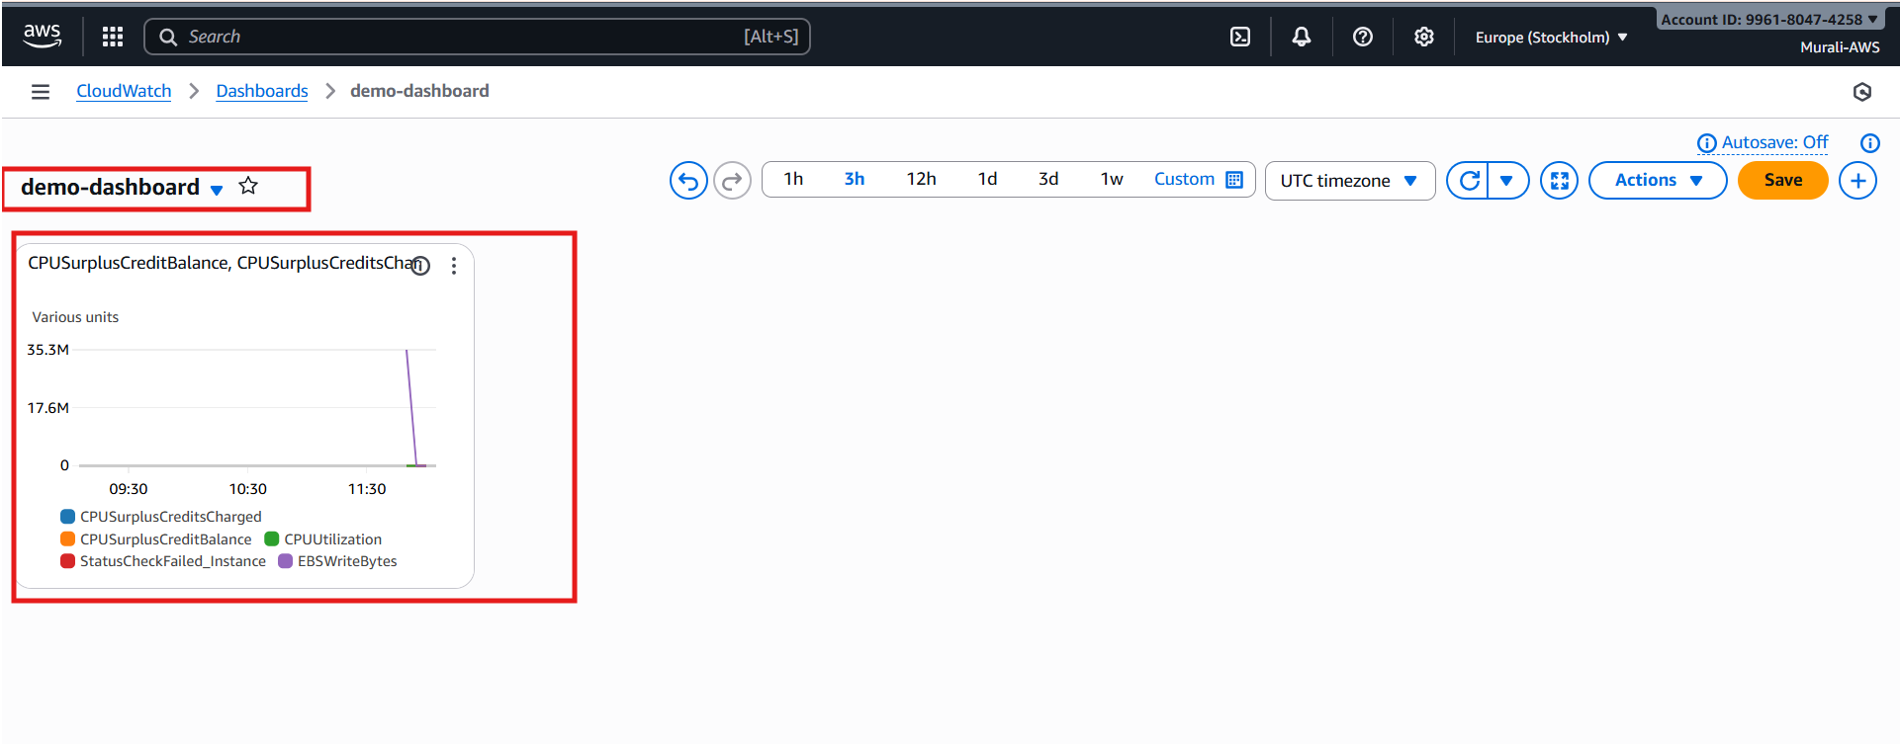
- After creating widget make sure click on save button (if not ur widget won’t save)
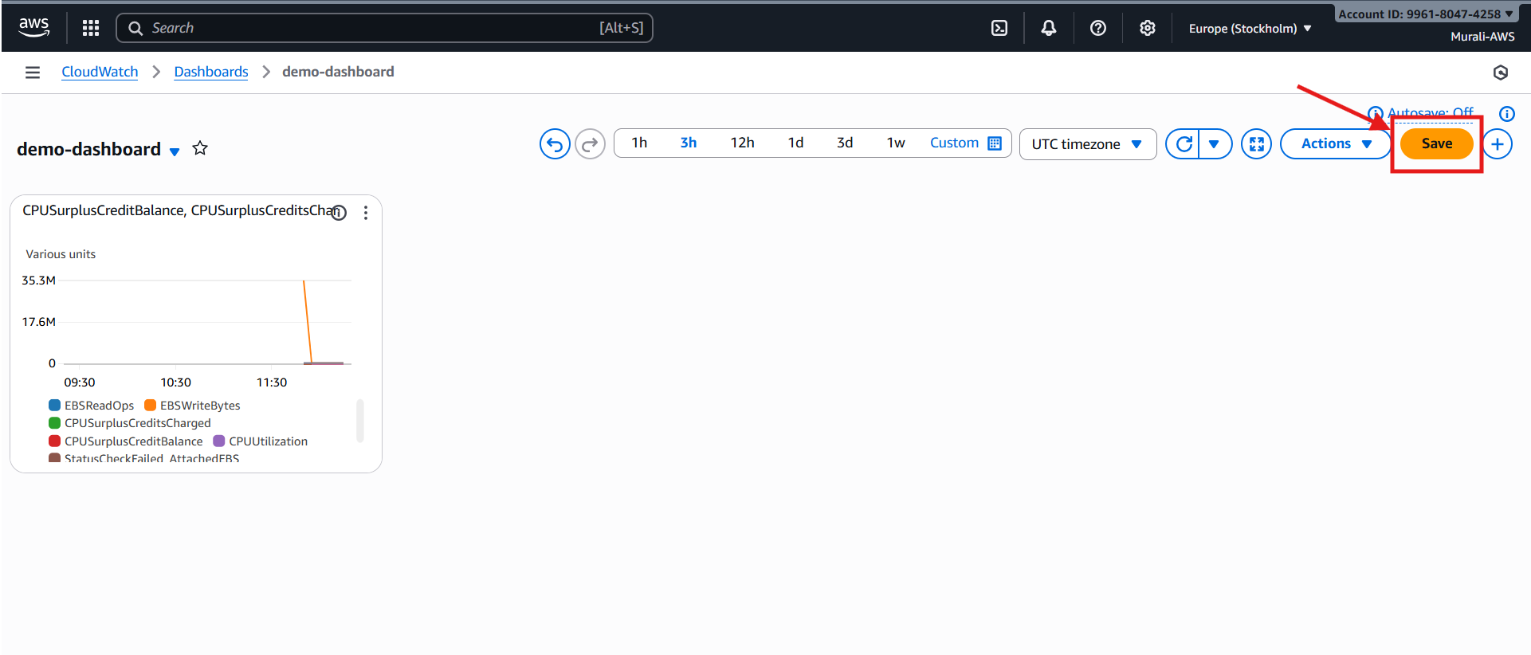

- Maximize the widget
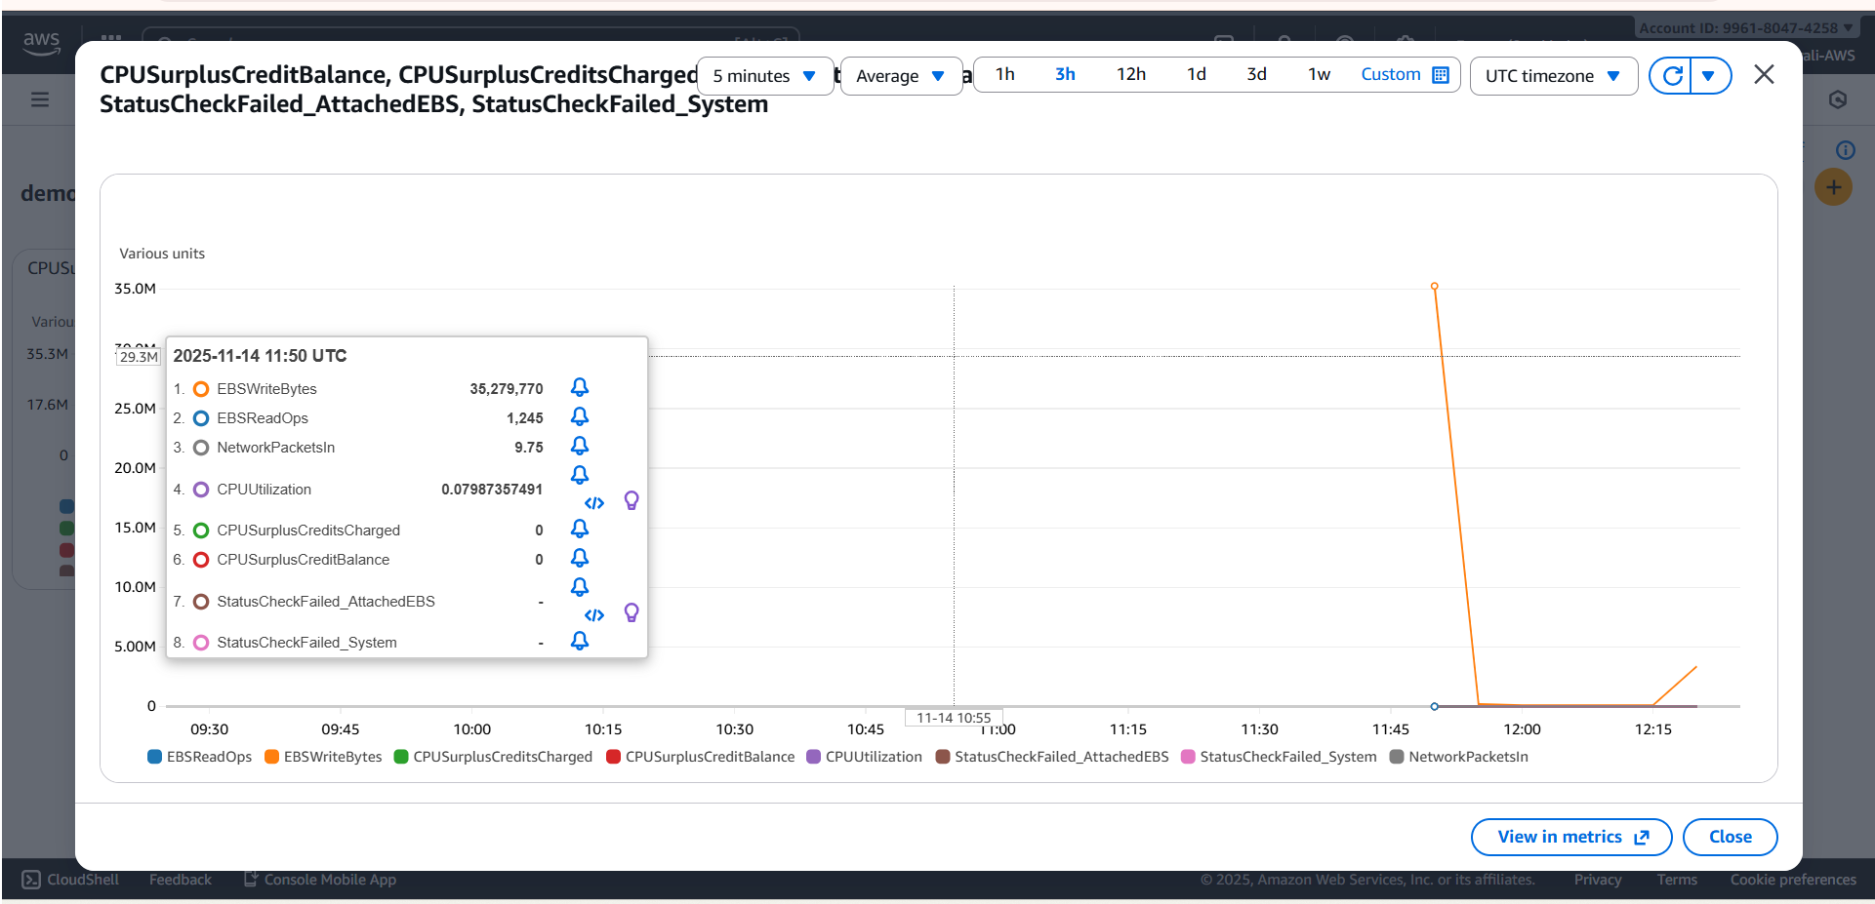
- Click on view metrics
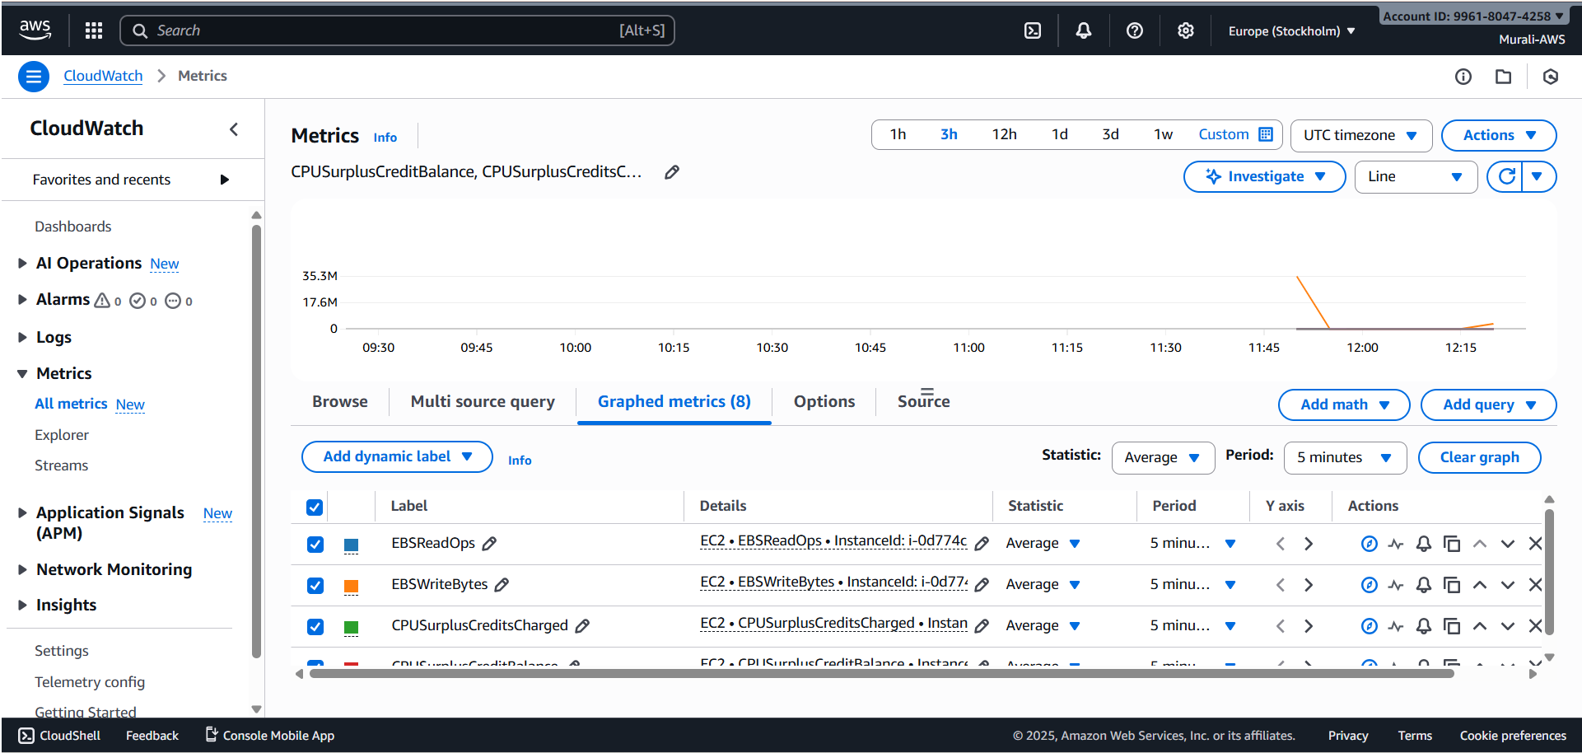

- Now we can set alarms for each metric and to set alarm click bell symbol on metric
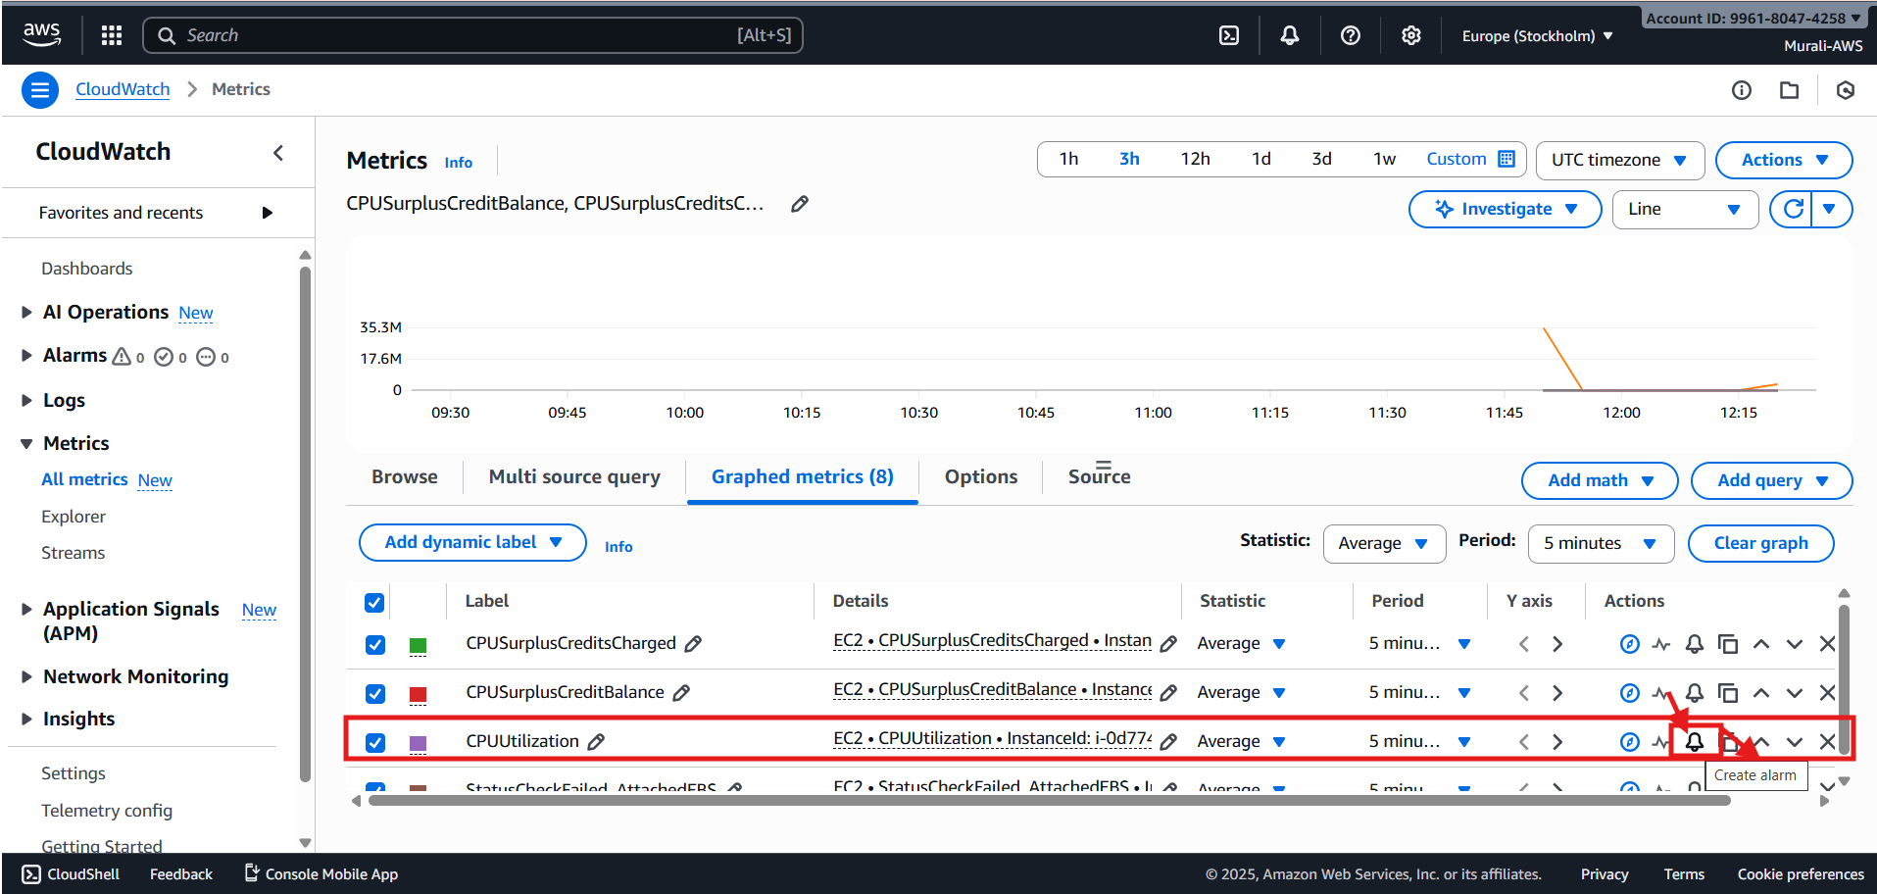

- You will get page like this and do following marked confirmation
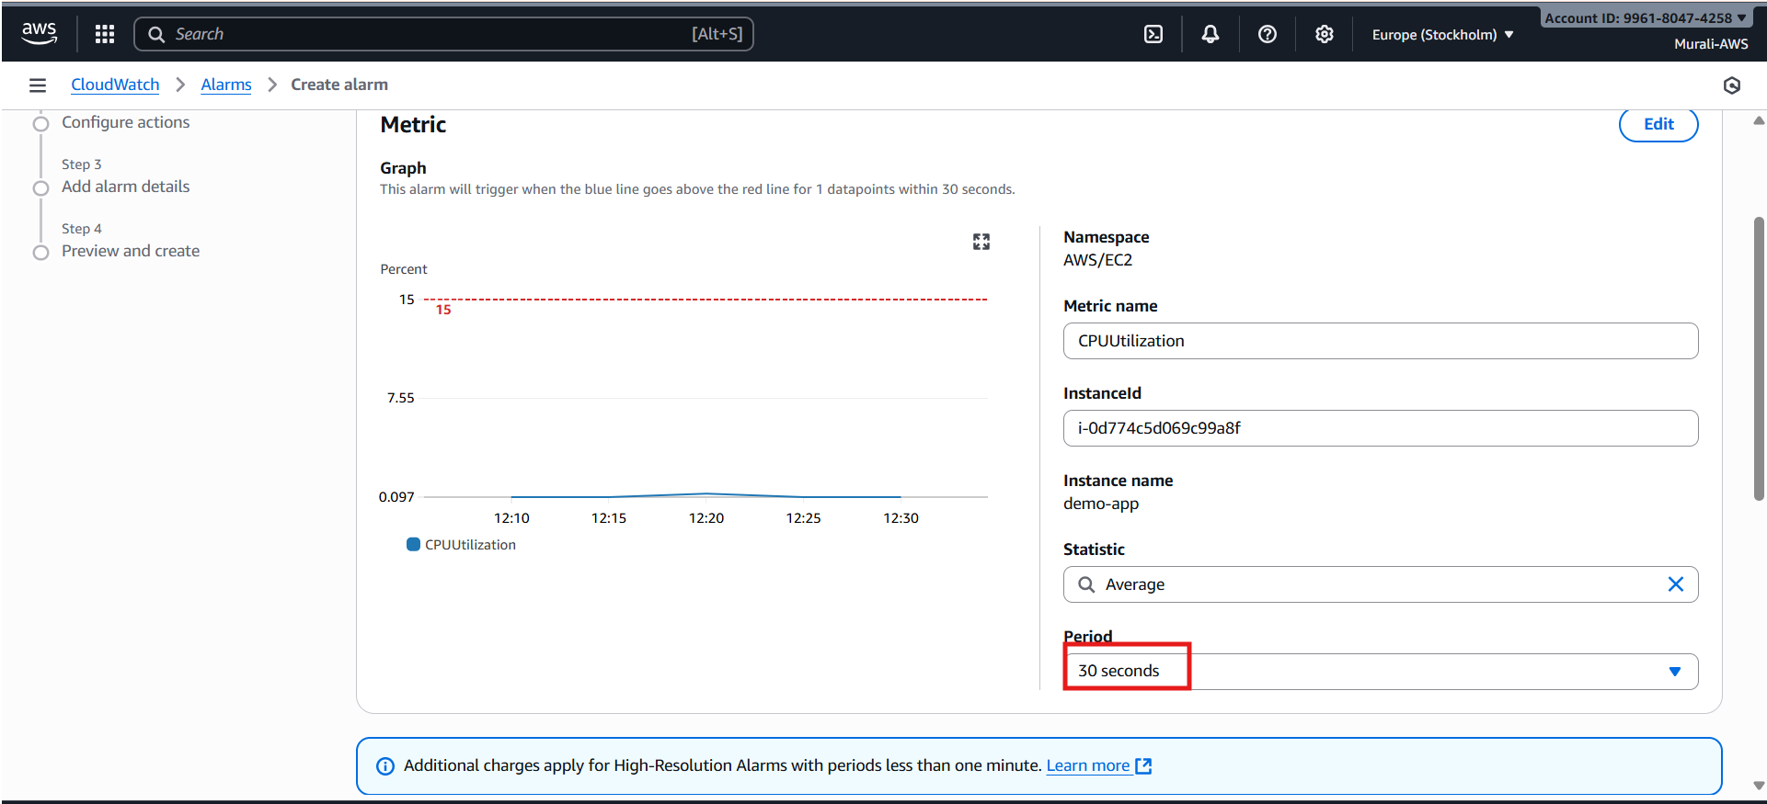

- Next do the following configurations
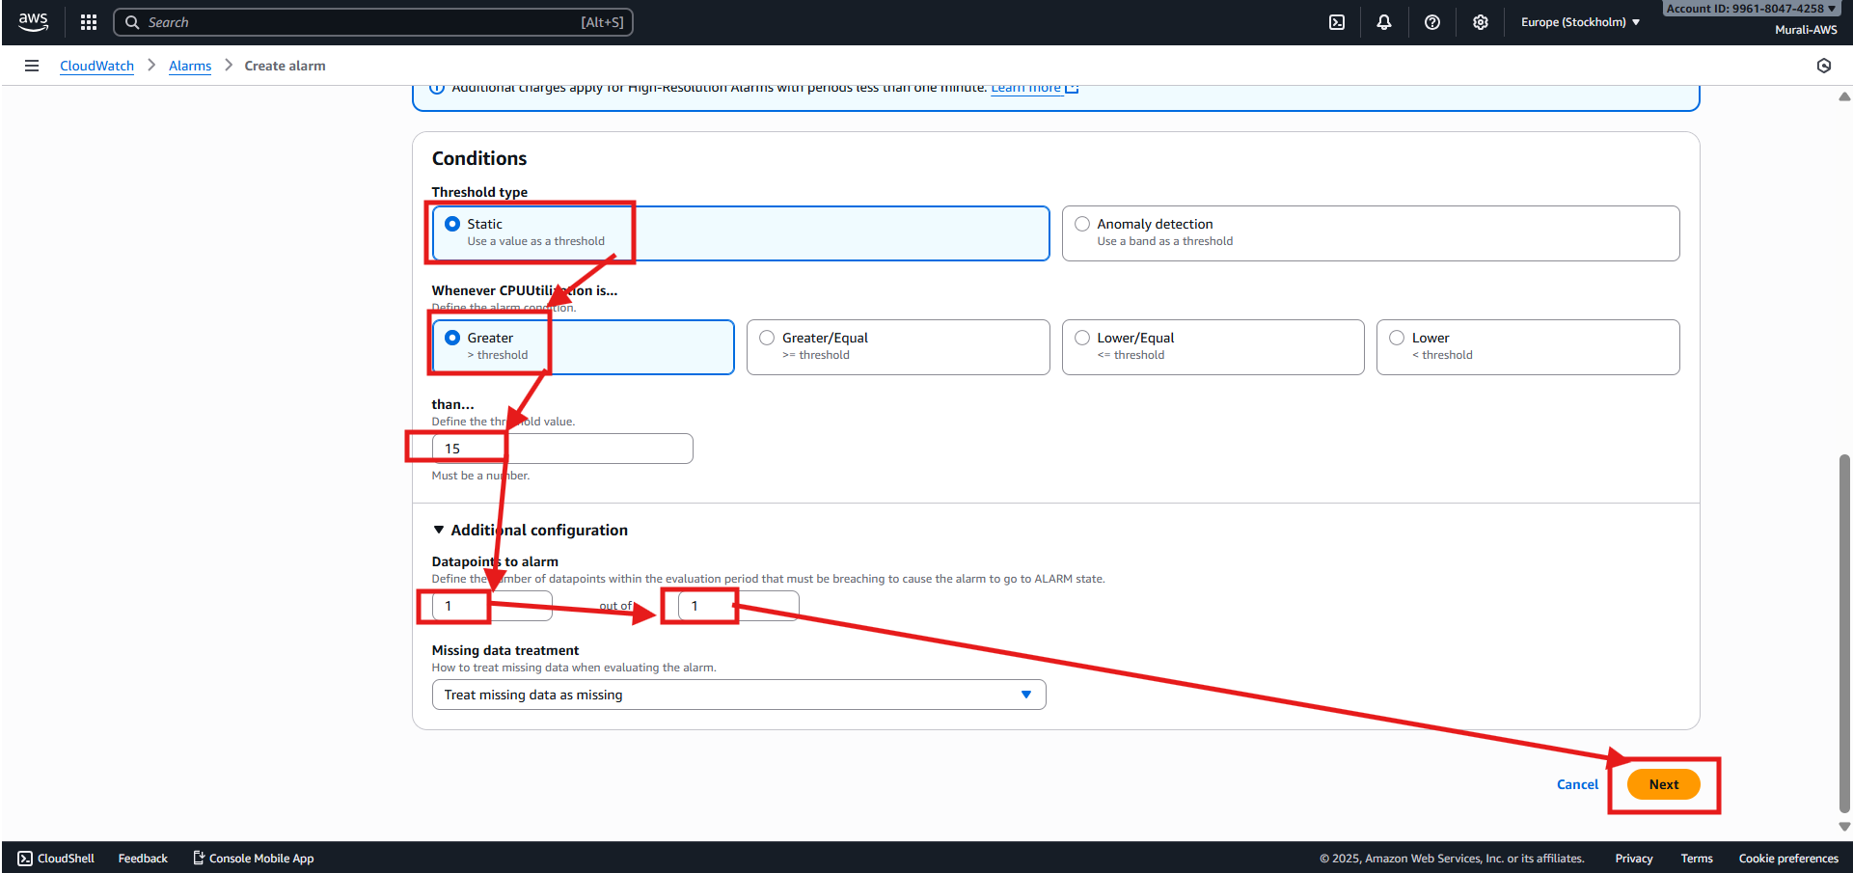

- Do the following configurations
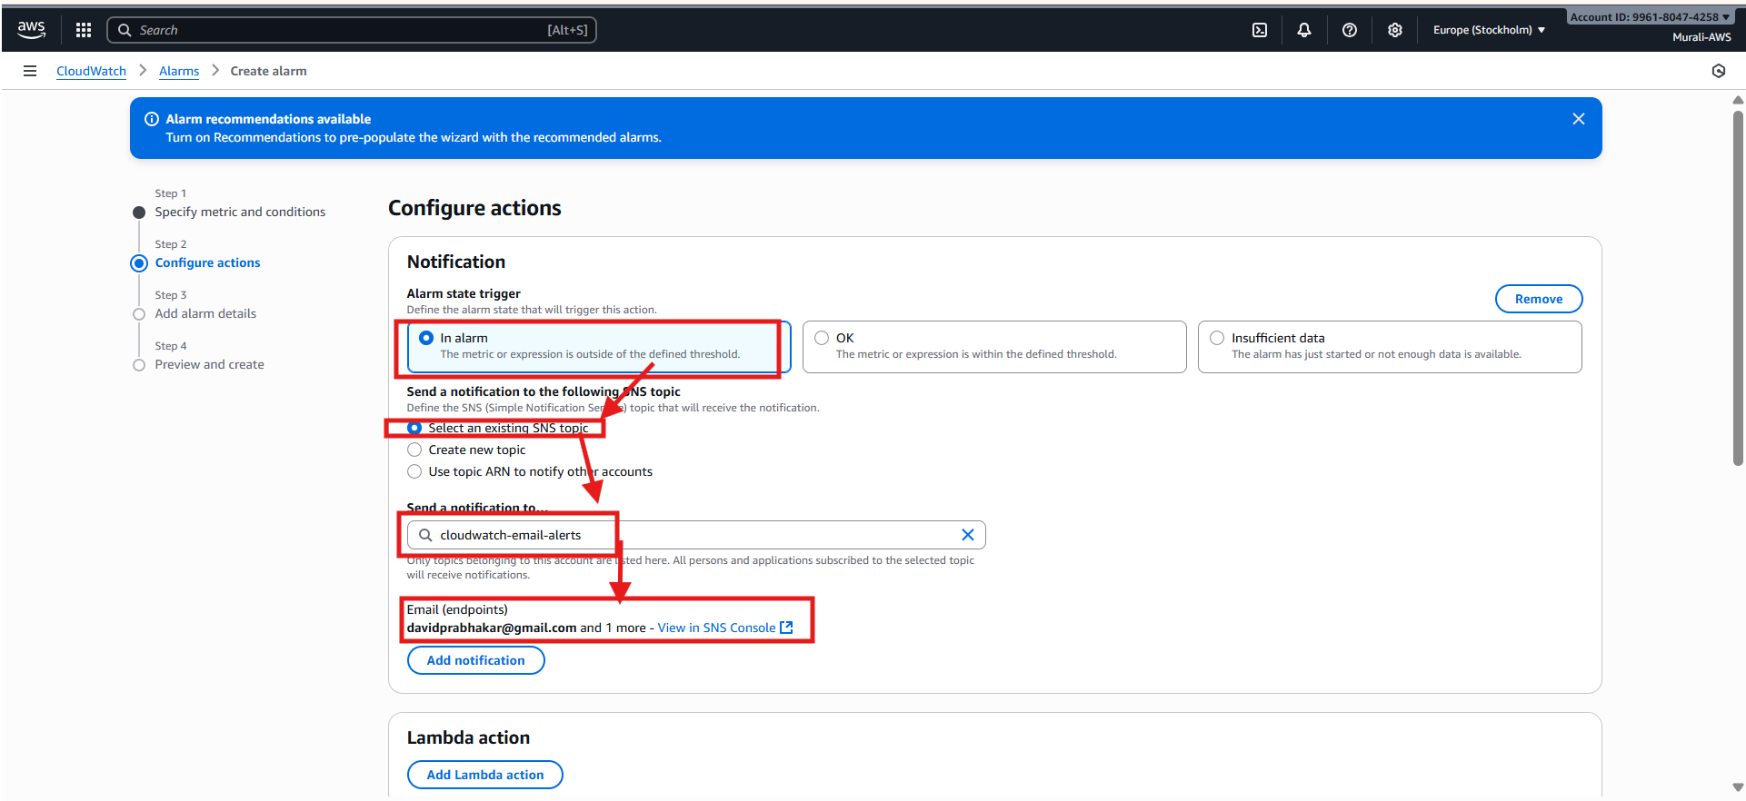

- Click on next
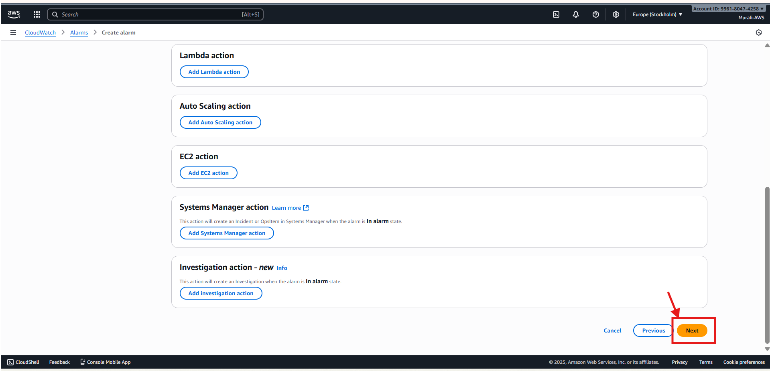

- Set a name for alarm and do following configurations
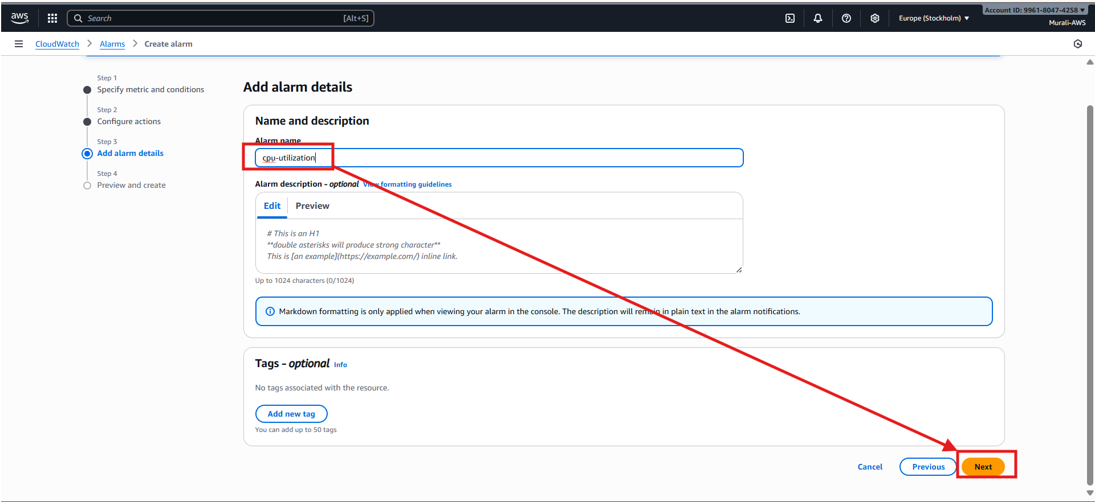

- Next preview and click on create alarm
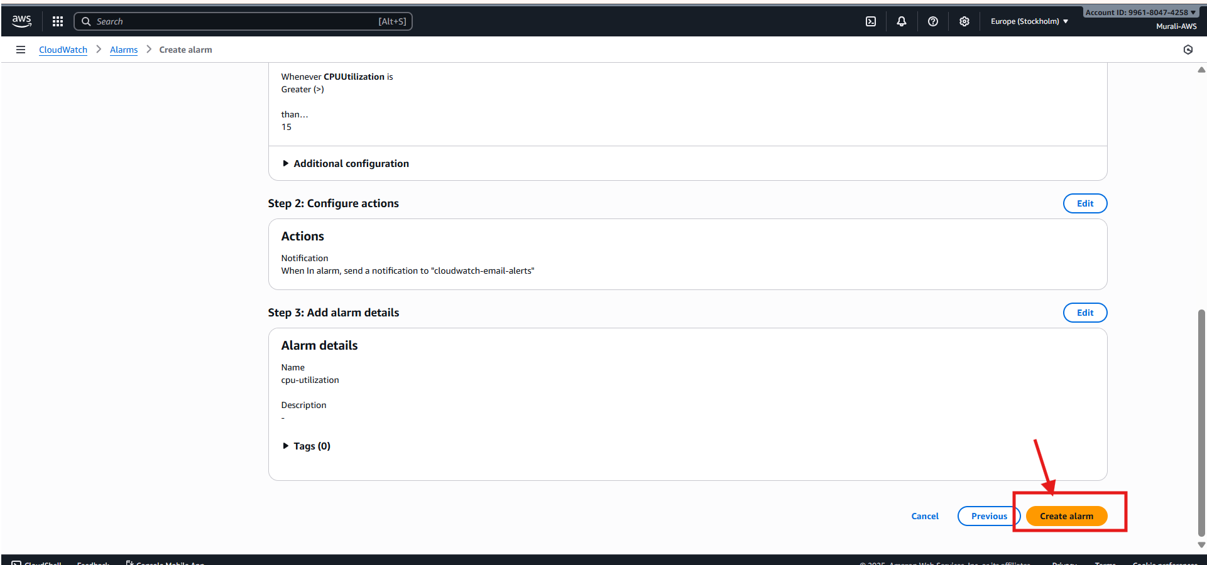

- Alarm created successfully
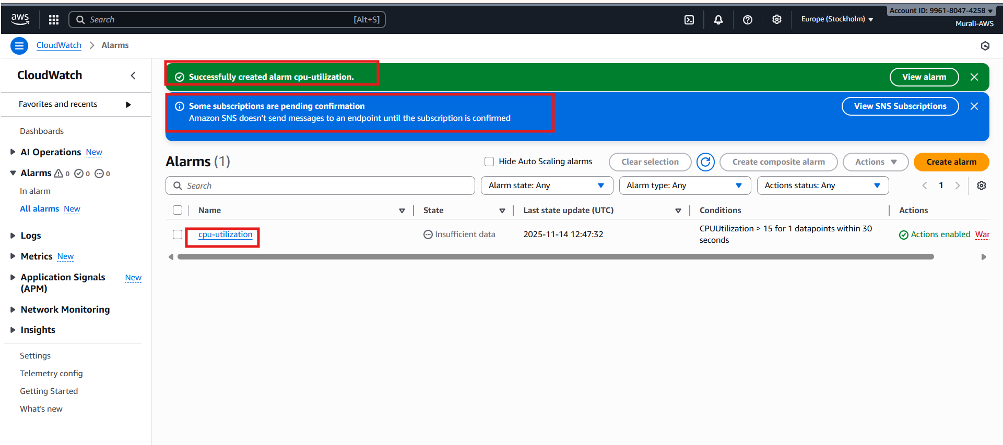

- Overview of alarm
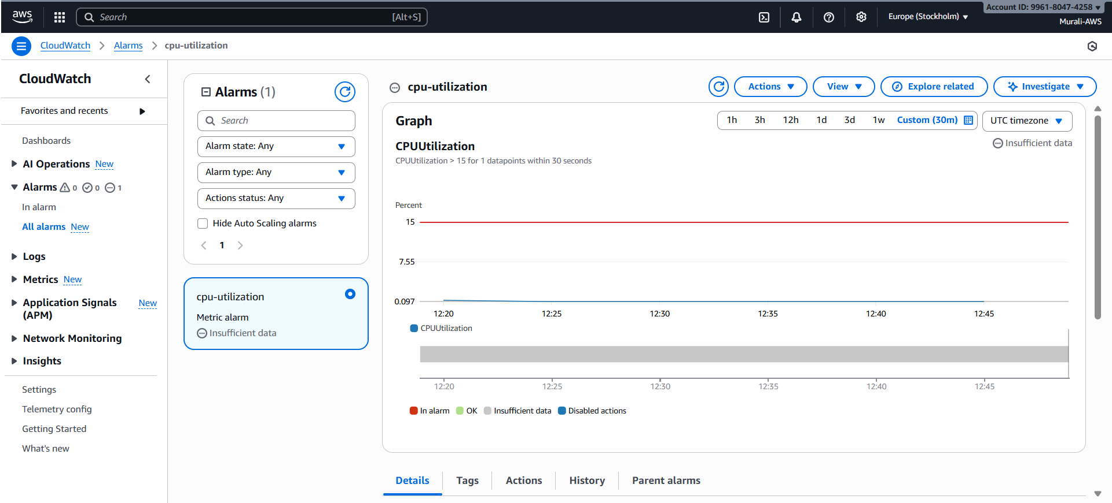

STEP 3: Create a CloudWatch Alarm
- Go to AWS Console → CloudWatch
- In left menu → click Alarms
- Click Create alarm
- Click Select metric
Choose a metric depending on what you want to monitor:
Examples:
- EC2 → CPUUtilization
- RDS → FreeStorageSpace
- Lambda → Errors
- ECS → CPUUtilization or MemoryUtilization
- Billing Alarm → AWS/Billing → EstimatedCharges
Once you select the metric → Click Select metric

